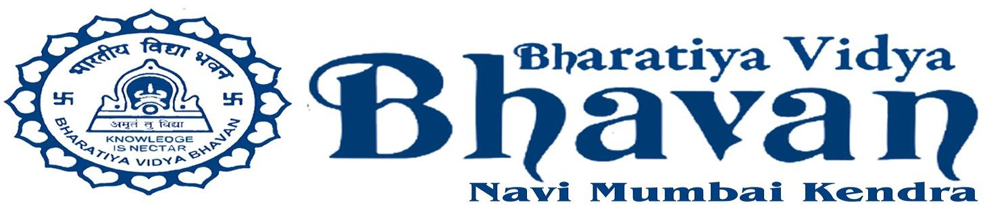

SANGEET BAITHAK STUDIO INAUGURATION
Is association with

BHARATIYA VIDYA BHAVAN NAVI MUMBAI KENDRA

Presents

Hindustani Classical vocal recital by
Pandit Sanjeev Chimmalgi

accompanied by

Pandit Vishwanath Shirodkar on Tabla
&
Vidushi Seema Shirodkar on Harmonium

Saturday, 2nd August 2025
from 5.00pm to 8.00pm.

Venue :- Bharatiya Vidya Bhavan Navi Mumbai Kendra,
Plot no. 3A, Sector – 30, Vashi, Navi Mumbai – 400 703.

Entry is free to all music lovers. Confirmation is mandatory on 9310865656.

